Hexaware Python Training – Day 1
Set 1 – Retail Order Desk
- Task 1 – Linear and Binary Search
Linear Search
# Linear Search Pseudocode
#START
# LOAD orders.csv
# INPUT targetOrderId
# FOR each order in orders DO
# IF order.orderId == targetOrderId THEN
# PRINT "Order Found"
# PRINT order details
# STOP
# END IF
# END FOR
# PRINT "Order Not Found"
#END

# Python Code
import csv

orders = []

with open("orders.csv","r",newline = "") as file:
reader = csv.DictReader(file)
for row in reader:
orders.append(row)

def linear_search(orders,target_id):
for order in orders :
if order["orderId"] == target_id:
return order
return None

target_id = input("Enter Order ID: ").strip()
result = linear_search(orders,target_id)

if result is not None:
print("\nOrder Found!")
print("Order ID:", result["orderId"])
print("Customer ID:", result["customerId"])
print("Amount:", result["amount"])
print("Created At:", result["createdAt"])
else:
print("\nOrder Not Found")
Binary Search
#Binary Search Pesudocode
#START
# LOAD orders.csv
# SORT orders by orderId in ascending order
# INPUT targetOrderId
# SET low = 0
# SET high = length(orders) - 1
# WHILE low <= high DO
# SET mid = (low + high) // 2
# IF orders[mid].orderId == targetOrderId THEN
# PRINT "Order Found"
# PRINT order details
# STOP
# ELSE IF orders[mid].orderId < targetOrderId THEN
# SET low = mid + 1
# ELSE
# SET high = mid - 1
# END IF
# END WHILE
# PRINT "Order Not Found"
#END
# Python Code
import csv

orders = []
with open("orders.csv", "r", newline="") as file:
reader = csv.DictReader(file)
for row in reader:
orders.append(row)

orders.sort(key=lambda order: order["orderId"])

def binary_search(orders, target_id):
low = 0
high = len(orders) - 1
while low <= high:
mid = (low + high) // 2
if orders[mid]["orderId"] == target_id:
return orders[mid]
elif orders[mid]["orderId"] < target_id:
low = mid + 1
else:
high = mid - 1
return None

target_id = input("Enter Order ID: ").strip()
result = binary_search(orders, target_id)

if result is not None:
print("\nOrder Found!")
print("Order ID:", result["orderId"])
print("Customer ID:", result["customerId"])
print("Amount:", result["amount"])
print("Created At:", result["createdAt"])
else:
print("\nOrder Not Found")
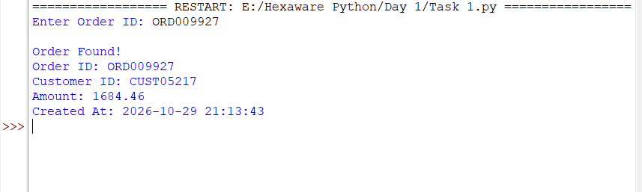
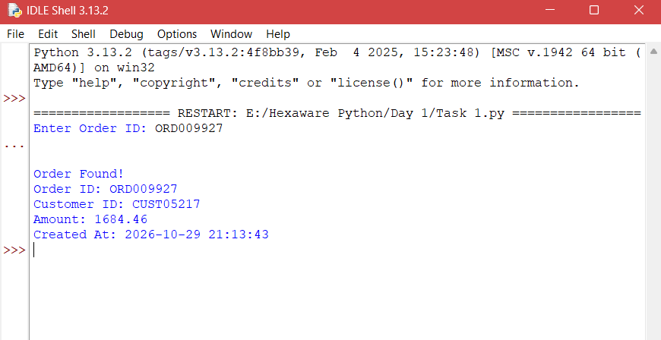
Console Output:

Time Complexity:
Linear Search : O(n)
Binary Search : O(log n)
Task 2 – Sorting
Bubble sort
# Bubble Sort Pseudocode
#START
# LOAD orders.csv
# SET n = length(orders)
# FOR i = 0 TO n - 1 DO
# FOR j = 0 TO n - i - 2 DO
# IF orders[j].amount < orders[j + 1].amount THEN
# SWAP orders[j] AND orders[j + 1]
# END IF
# END FOR
# END FOR
# PRINT sorted orders
#END
Passes:
example let this list be the initial : [500, 250, 900, 300, 700]
500, 250, 900, 300, 700
500, 900, 250, 300, 700
900, 500, 250, 300, 700
Merge Sort :

# Merge Sort Pseudocode
#START
# LOAD orders.csv
# CALL merge_sort(orders)
# FUNCTION merge_sort(orders)
# IF length(orders) <= 1 THEN
# RETURN orders
# END IF
# SET mid = length(orders) // 2
# DIVIDE orders into left and right
# SET left = merge_sort(left)
# SET right = merge_sort(right)
# MERGE left and right in descending order
# RETURN merged list
# END FUNCTION
# PRINT sorted orders
#END
Passes :
Let the initial be : [500, 250, 900, 300, 700]
[500, 250, 900] [300, 700]
[500] [250, 900] [300] [700]
[500] [900, 250] [700, 300]
Mergeing
[900, 500, 250] [700, 300]
[900, 700, 500, 300, 250]
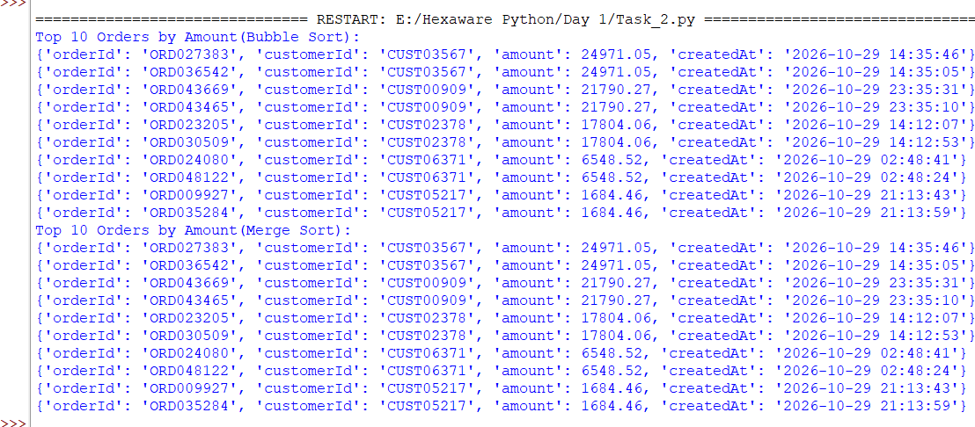

Time Complexity and Space Complexity :
Time Complexity: Bubble Sort - O(n²), Merge Sort - O(n log n), Built-in Sort - O(n log n).
Space Complexity: Bubble Sort - O(1), Merge Sort - O(n), Built-in Sort - O(n).

Task 3 – Duplicate Orders
# Duplicate Order Detection Pseudocode
#START
# LOAD orders.csv
# CREATE an empty hash_map
# FOR each order in orders DO
# EXTRACT customerId, amount and createdAt
# EXTRACT date and time up to the minute
# CREATE key = (customerId, amount, minute)
# IF key exists in hash_map THEN
# PRINT "Duplicate Order Found"
# PRINT previous order and current order
# ELSE
# STORE order in hash_map using key
# END IF
# END FOR
#END
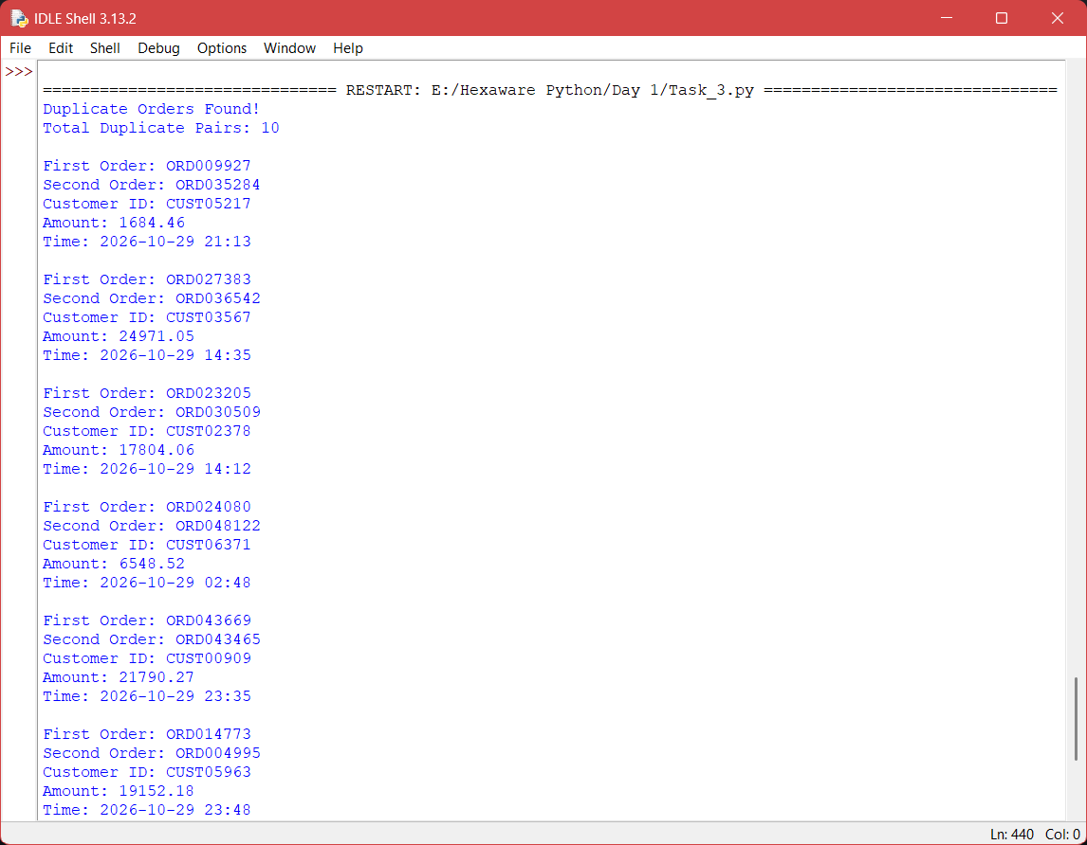
Console Output :

Task 4 – Stack and queue
# Stack and Queue Pseudocode
#START
# CREATE a Stack
# CREATE an empty list to store elements
# DEFINE PUSH operation
# ADD element to the top of Stack
# DEFINE POP operation
# IF Stack is not empty THEN
# REMOVE and RETURN top element
# ELSE
# PRINT "Stack is Empty"
# END IF
# CREATE a Queue
# CREATE an empty list to store elements
# DEFINE ENQUEUE operation
# ADD element to the rear of Queue
# DEFINE DEQUEUE operation
# IF Queue is not empty THEN
# REMOVE and RETURN front element
# ELSE
# PRINT "Queue is Empty"
# END IF
# PUSH order edits into Stack
# POP last edit to perform undo
# ENQUEUE orders into Queue
# DEQUEUE orders for dispatch
# REPLACE custom Stack with built-in List
# REPLACE custom Queue with built-in Deque
#END

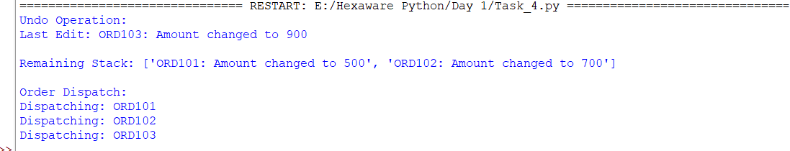
Time Complexity:
Stack Push/Pop - O(1), Queue Enqueue - O(1), Custom Queue Dequeue - O(n), Built-in Deque Dequeue - O(1).
Space Complexity: Stack and Queue - O(n) for both custom and built-in implementations.
Task 5 – Greedy Algorithm
# Greedy Algorithm Pseudocode
#START
# INPUT refund_amount
# SET denominations = [4, 3, 1]
# SET count = 0
# FOR each denomination in denominations DO
# WHILE refund_amount >= denomination DO
# SUBTRACT denomination from refund_amount
# INCREMENT count
# END WHILE
# END FOR
# PRINT minimum number of coins
#END
Console Output :
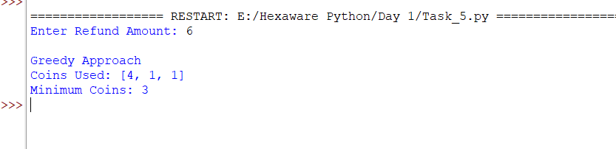
fails as the output is 2 [3, 3]
Dynamic Programming:
# Dynamic Programming Pseudocode
#START
# INPUT refund_amount
# SET denominations = [1, 3, 4]
# CREATE dp array of size refund_amount + 1
# INITIALIZE all values to infinity
# SET dp[0] = 0
# FOR amount = 1 TO refund_amount DO
# FOR each coin in denominations DO
# IF amount >= coin THEN
# dp[amount] = MIN(dp[amount],
# dp[amount - coin] + 1)
# END IF
# END FOR
# END FOR
# PRINT dp[refund_amount]
#END
Console Output :
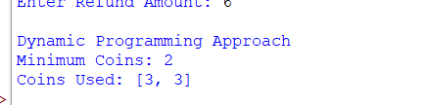

Time Complexity: Greedy - O(n × k), Dynamic Programming - O(A × k).
Space Complexity: Greedy - O(1) auxiliary space, Dynamic Programming - O(A).

